Go into the draw to win a $50 supermarket voucher
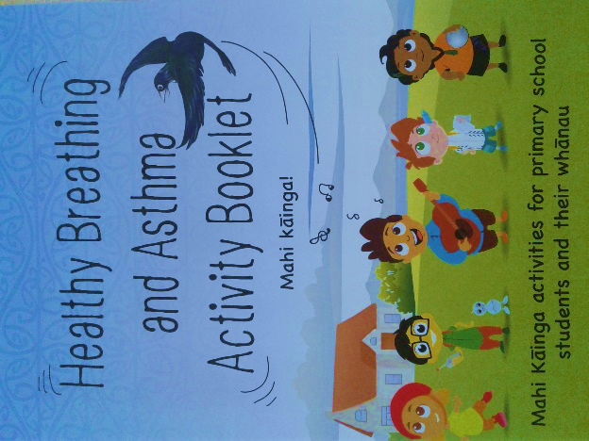
We hope you and your tamariki had fun completing the activities in the Healthy Breathing and Asthma Activity Booklet. Tell us what you and your whānau thought of this resource and you will go into the draw to win a $50 grocery voucher. Search this link to take part in the survey: https://surveymonkey.com/r/breathingactivities
We look forward to your feedback!

The He Kura Asthma Study team would love to talk to some parents/ caregivers about the asthma study that our school has been involved with this year. If you would like to take part in an interview or focus group (small group discussion) please contact the team on 0800 755 414 or email wtr@otago.ac.nz. Participating whānau will receive a $20 voucher for their time.

If you have not yet returned an Asthma Medical Form for your child, please get one from the office and return it to school.

