Catholic Schools Day
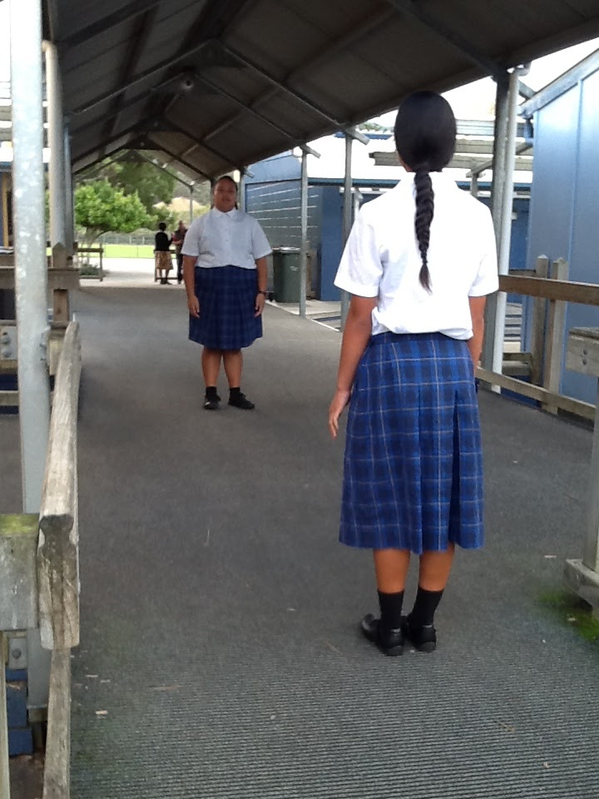
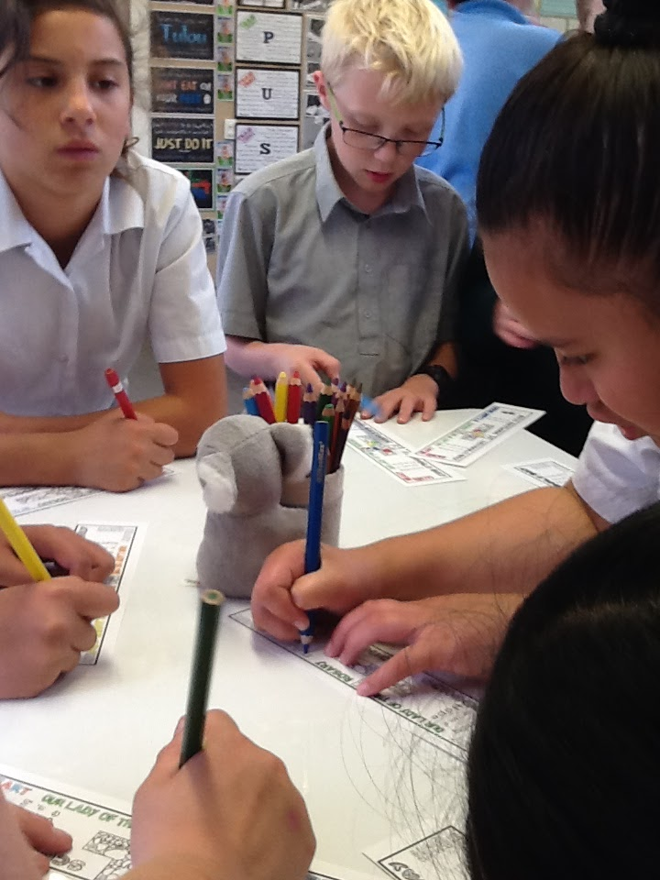
For us as Catholics, it’s important to get to know some of the other Catholic schools in our region, Wellington. On the 16th May it was Catholic Schools Day. The schools in our Parish, of The Holy Spirit- Te Wairua Tapu, shared the day together. The Year 7 and 8 students from Sacred Heart Petone, and Our Lady of the Rosary, came to us. They really enjoyed the day as we had planned a load of activities and games for them to play. It was really exciting for us all, as the time we had helped us connect with the other students from the schools.

Kaelin Van Driel
